Symbiosis Skills and Professional University



Skill Journal

**Name:** Yograj Anant Gadekar **Date:1**0-12-2021

**PRN:**

**School:** School of Data Science

**Course:** Data Associate (Data Science)

**Module Name:** Python for Data Analysis **/** Managing with Data **/** Analyzing Data from Disparate Sources **(tick any one)**

1. **Skill Activity Number–** 8
2. **Title-** Joins, Clauses and Sub queries in MySQL
3. **Skills / Competencies to be acquired:** MYSQL
4. **Duration**

2 days

1. **What is the purpose of the activity?**

Purpose of this activity joins brings different groups of data together on the basis of relationships.

1. **Steps Performed in this activity?**

1) Create Database and tables.

2) Insert values in tables.

3) Perform Inner join clause

4) Perform Left join clause

5) Perform Right join clause

6) Perform Cross join clause

7)Perform Natural join clause

8) Perform a subquery

1. **What resources / materials / equipment / tools did you use for this activity?**

MYSQL, MS-word

1. **What skills did you acquire?**

MYSQL

1. **Time taken to complete this activity?**

1 to 2 hours

# **Joins, Clauses and Sub queries in MySQL**

JOIN clauses are used to return the rows of two or more queries using two or more tables that shares a meaningful relationship based on a common set of values.

**Types of MySQL Joins :**

1. INNER JOIN
2. LEFT JOIN
3. RIGHT JOIN
4. CROSS JOIN
5. NATURAL JOIN

use database;

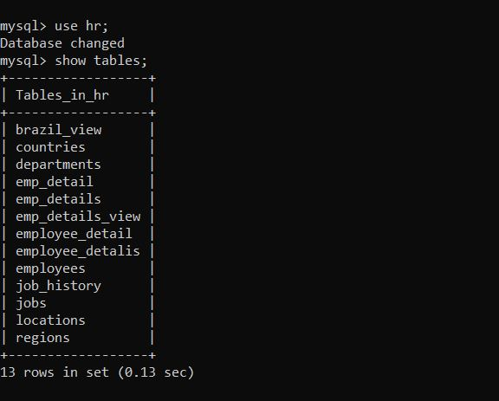

**Show tables data using select**

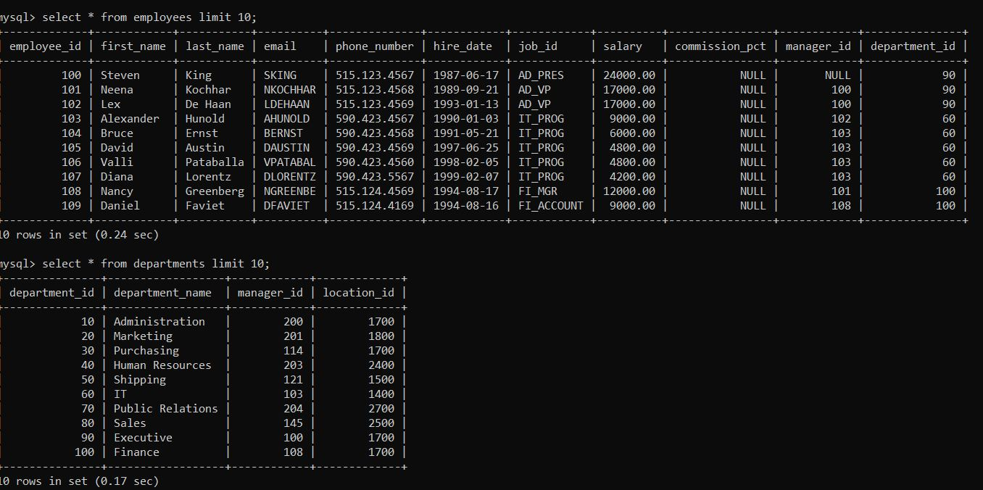

1. **INNER JOIN:**

It returns the common records that have matching values in both tables.

**Question.** Query to get the department name and number of employees in the department

**Query:**

select department_name,count(*) as 'No of emps' from departments as d inner join employees as e on e.department_id=d.department_id group by d.department_id,department_name order by department_name;

**Output:**

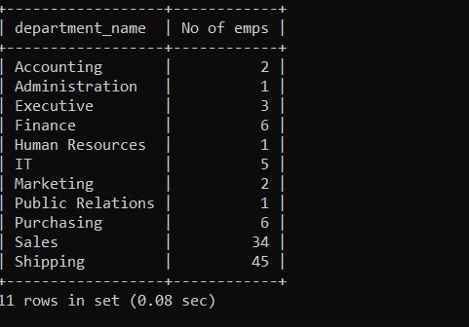

1. **LEFT JOIN:**

It returns all records from left table and match records from right table.

**Question1.** The following statement retrieves employee's id, name, hiring date and their department name by joining the *employees* and *departments* tables together using the common *dept_id* field. It also includes those employees who are not assigned to a department.

**Query:**

select e.employee_id,e.first_name,e.last_name,e.hire_date,d.department_name from employees as e left join departments as d on e.department_id=d.department_id order by employee_id;

**Output:**

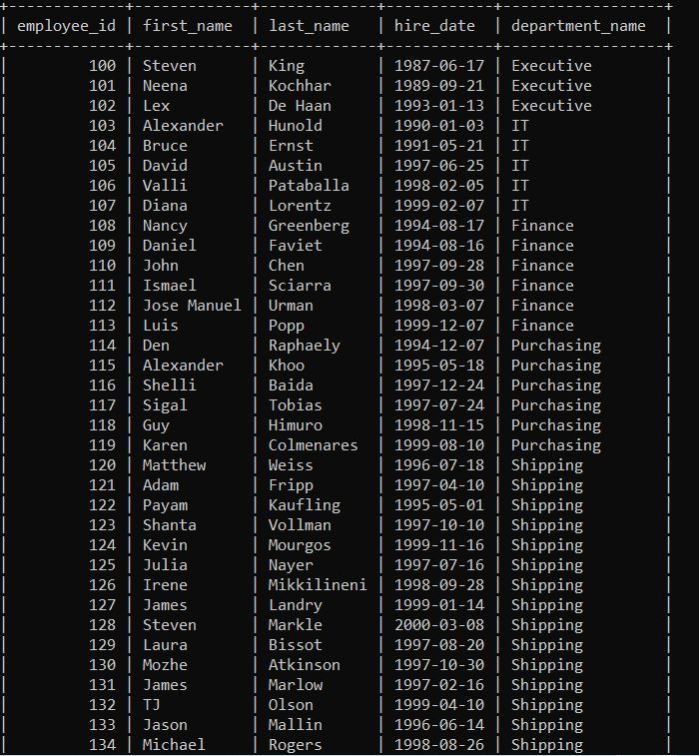

1. **RIGHT JOIN:**

It returns all records from right table and match records from left table.

**Question1.** The following statement retrieves all the available departments as well as the id, name, hiring date of the employees who belongs to that department by joining the *employees* and *departments* tables together using the common *dept_id* field.

**Query:**

Select e.employee_id,e.first_name,e.last_name,e.hire_date,d.department_name from employees as e right join departments as d on e.department_id=d.department_id order by department_name;

**Output:** 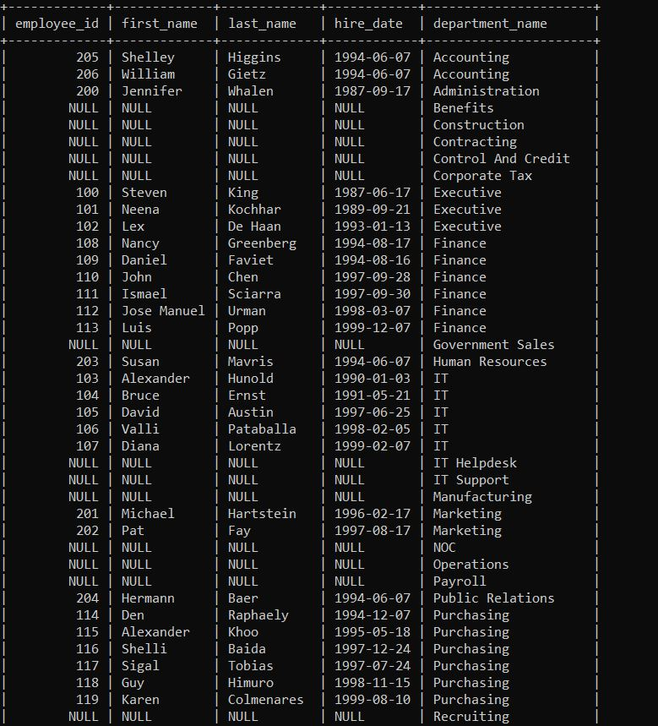

1. **CROSS JOIN:**

It combines all rows from both tables and return cartesian product of tables.

**Question1.** Following statement retrieve the cartesian product of employees and departments table.

**Query:**

select * from employees cross join departments;

**Output:**

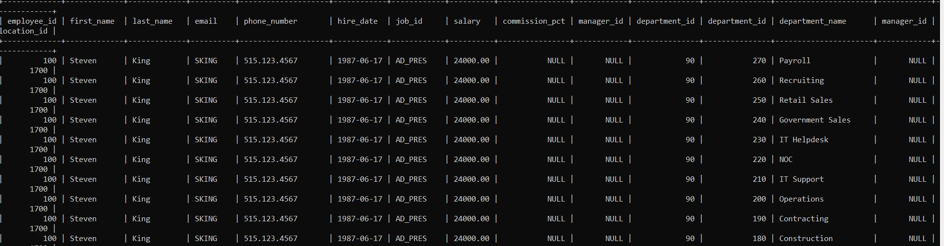

1. **NATURAL JOIN:**

**Question1.** Query to display the job title and average salary of employees**.**

**Query:**

select job_title,avg(salary)from employees natural join jobs group by job_title;

**Output:**

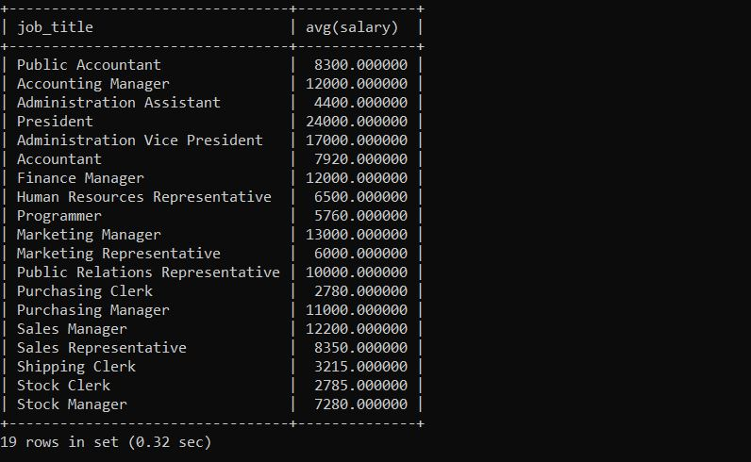

**Sub queries in MySQL**

A MySQL subquery is a query nested within another query such as SELECT,INSERT,UPDATE or DELETE. Also, a subquery can be nested within another subquery.

It returns either single value or row set.

**Q1.** Write a query to find the name (first_name, last_name) of all employees who works in the IT department.

**Query:** select first_name,last_name from employees where department_id in(select department_id from departments where department_name='IT');

**Output:**

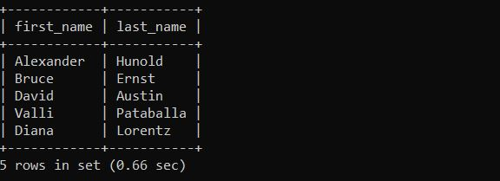

**Q2.** Write a query to find the name (first_name, last_name) of the employees who are managers.

**Query:** select first_name,last_name from employees where(employee_id in(select manager_id from employees));

**Output:**

